**DATA ANALYSIS USING PYTHON**

**PRACTICAL LAB BOOK**

**Submitted by:**

**NEHA SINHA**

**18BBTCS075**

**CSE, Section - ‘A’**

**1. BASICS**

**Learning objective: To implement basics of python language**

**Learning outcome: Understanding of basics in python language**

**Steps involved:**

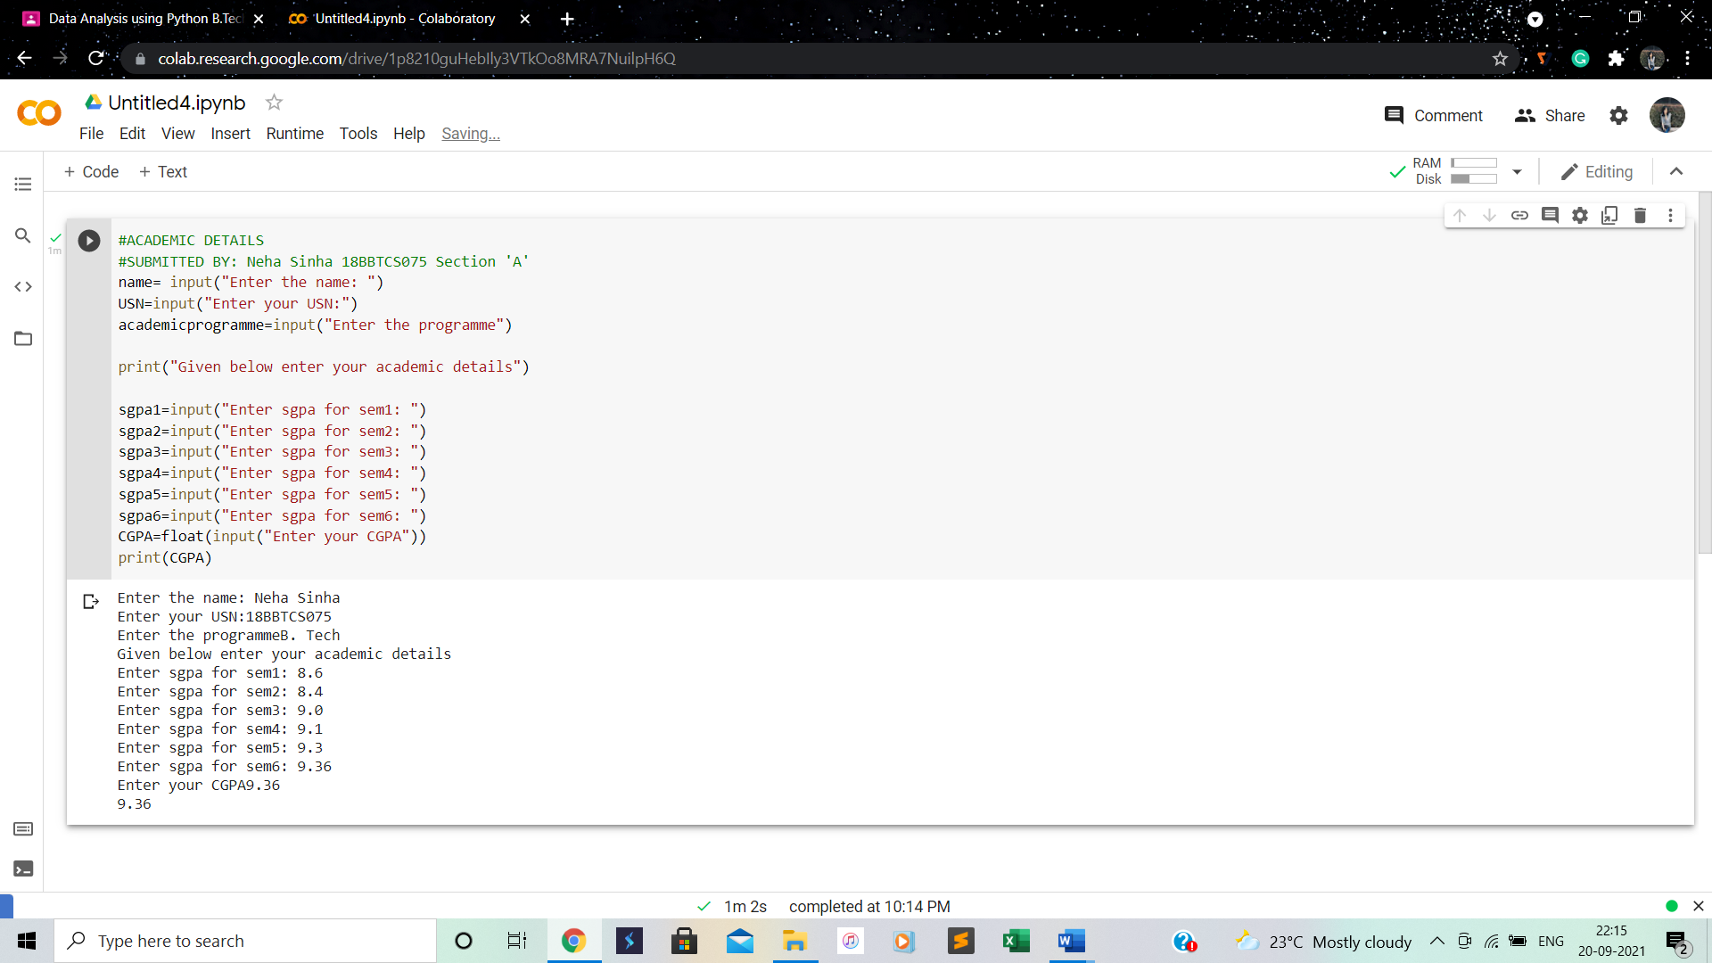

**Conclusion: Implemented basics of python language.**

**2.IF ELSE, LISTS, STRINGS AND LOOPS (including break and continue):**

**Learning objective: To implement if-else, lists, string and loops**

**Learning outcome: Understanding of if-else, lists, string and loops in programs**

**Steps involved:**

1. **IF ELSE**

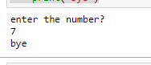

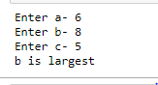

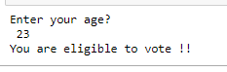

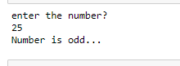

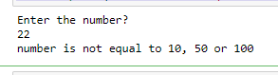

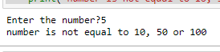

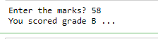

1. **LISTS:**

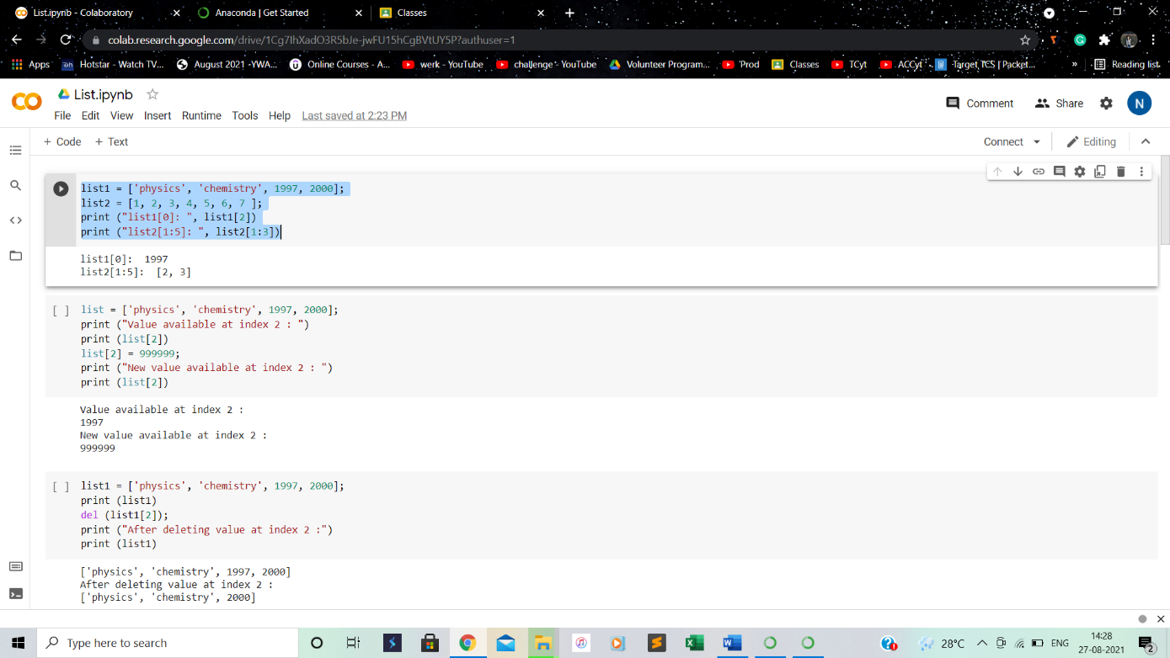

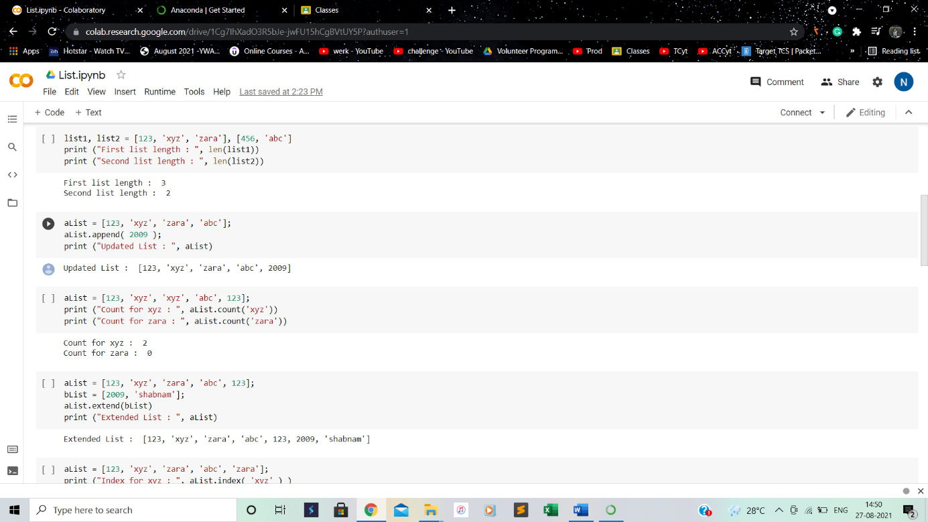

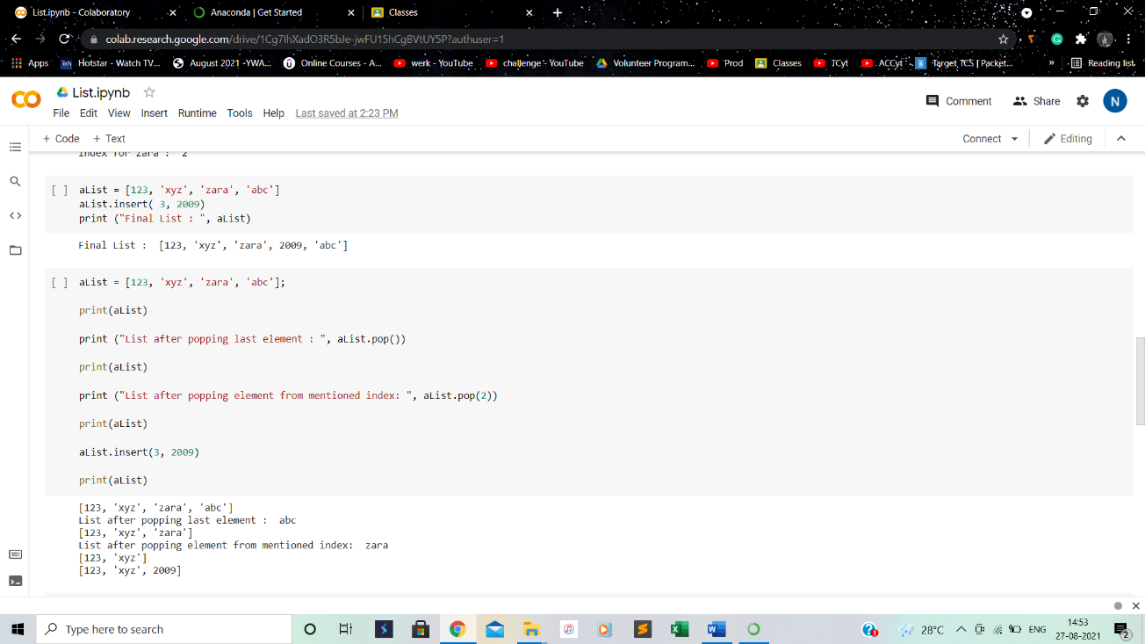

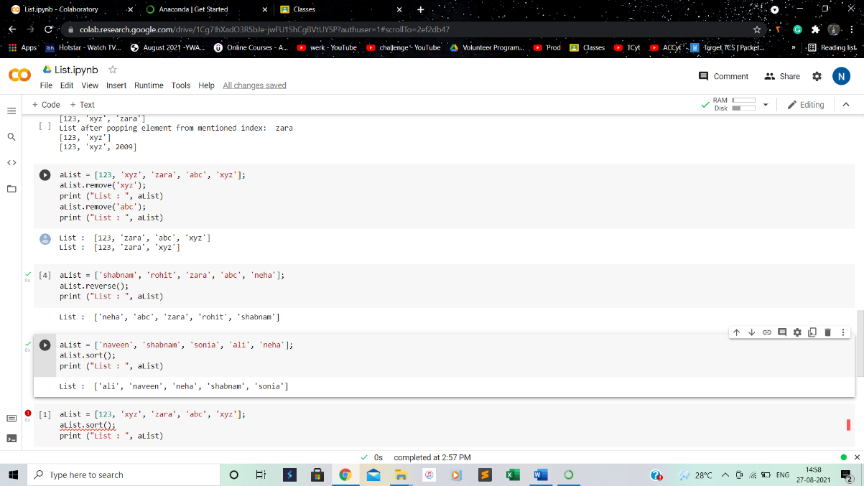

1. **STRINGS:**

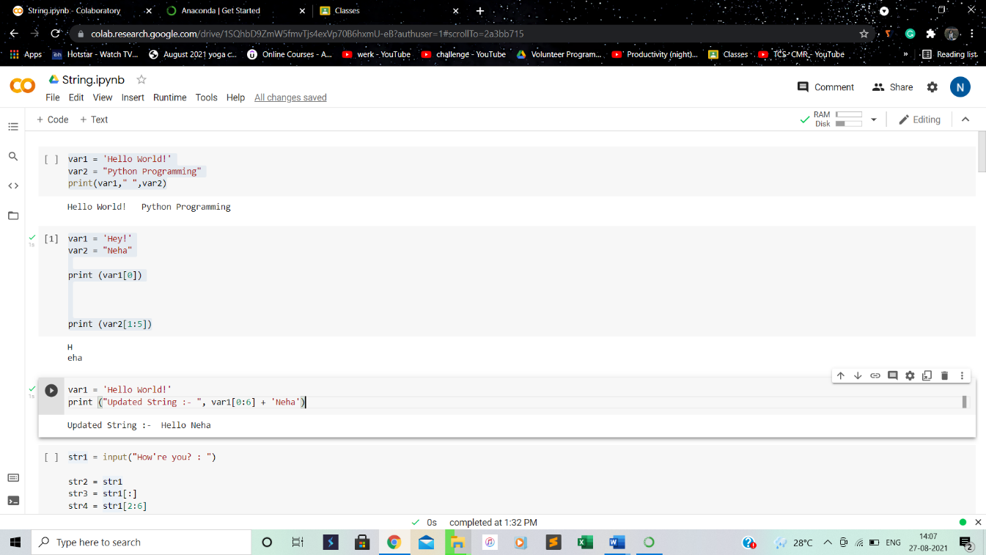

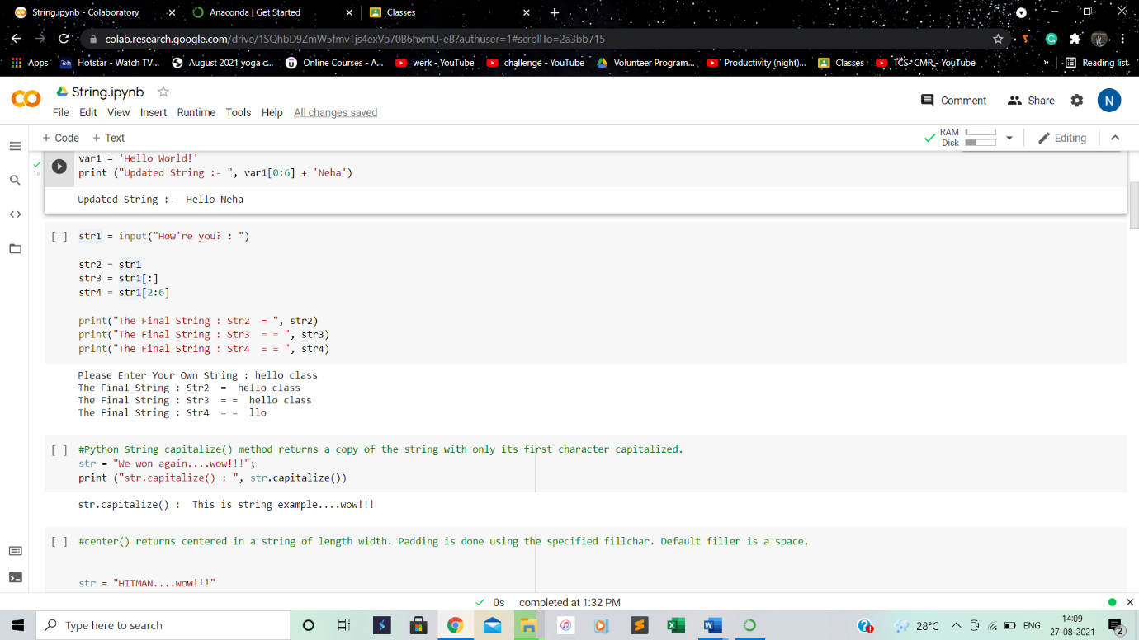

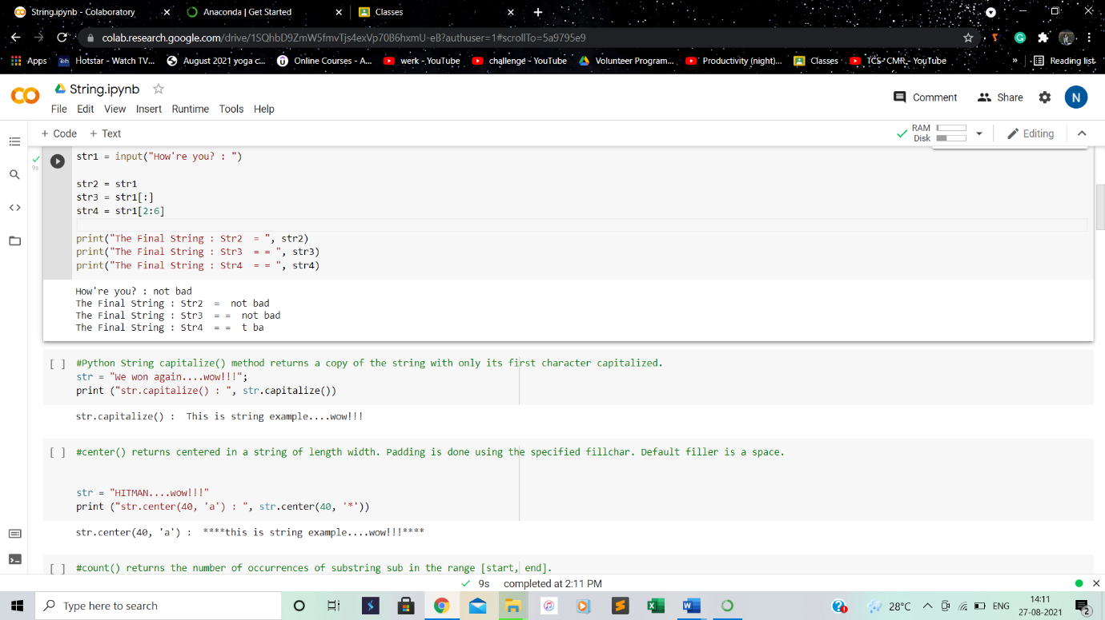

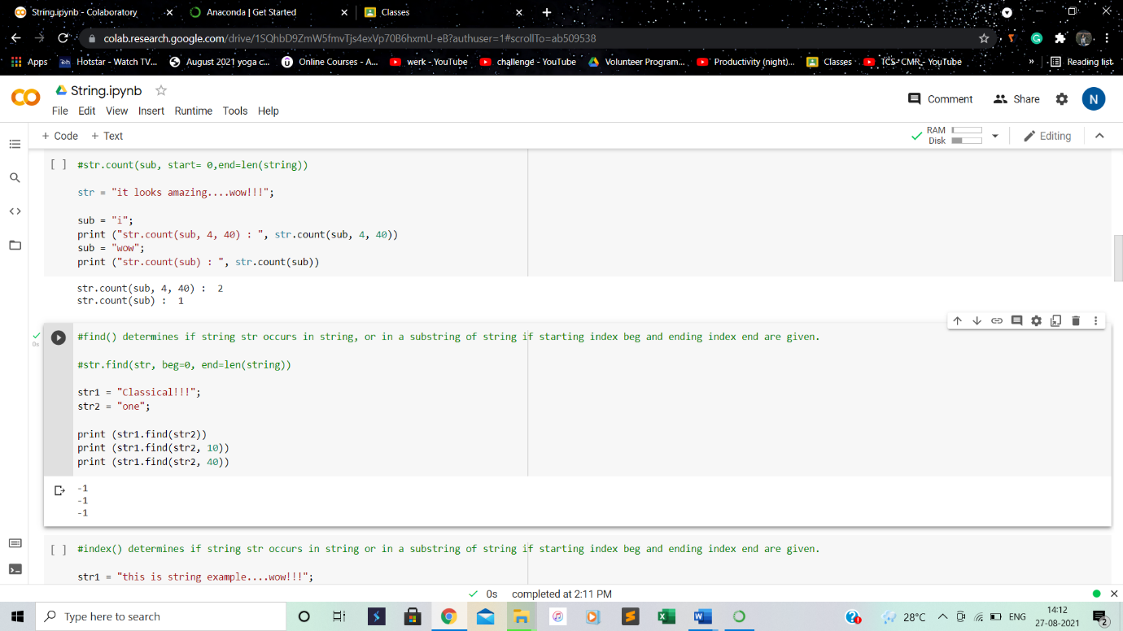

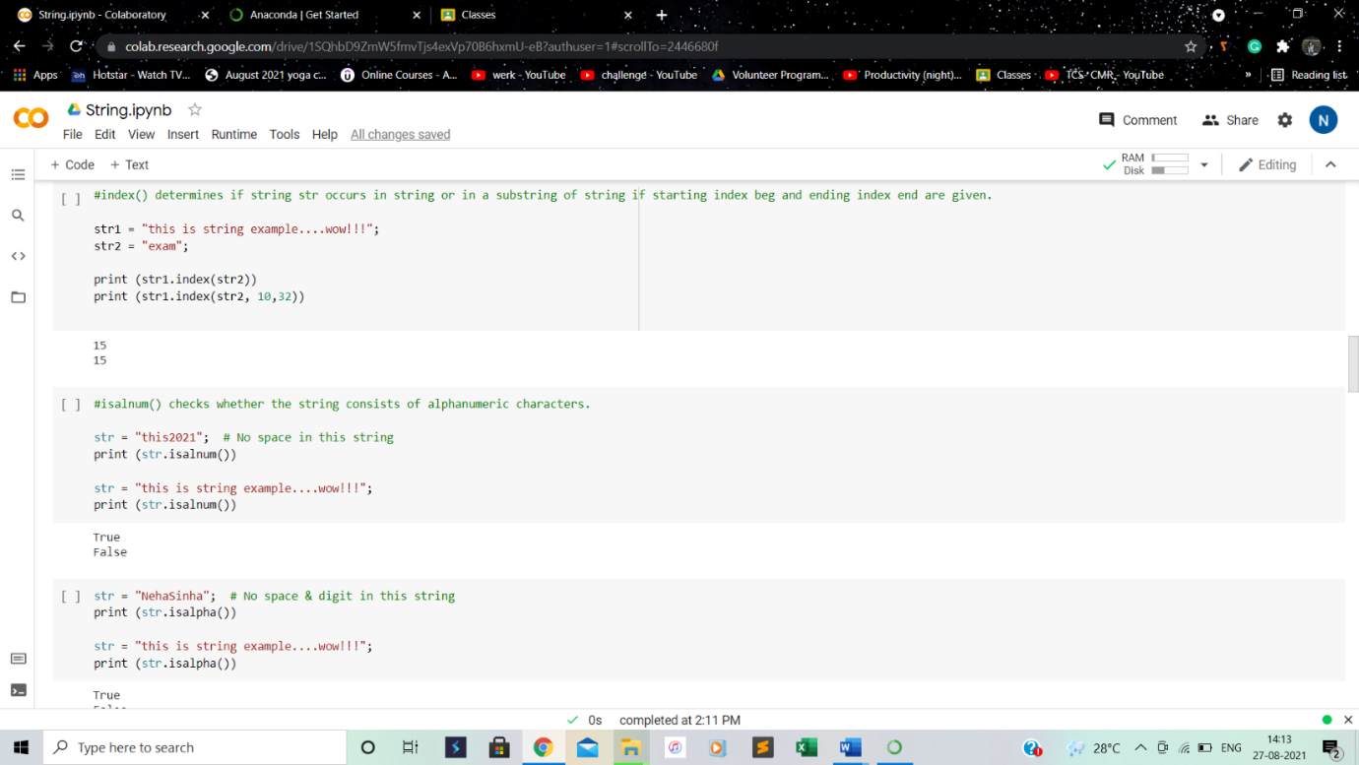

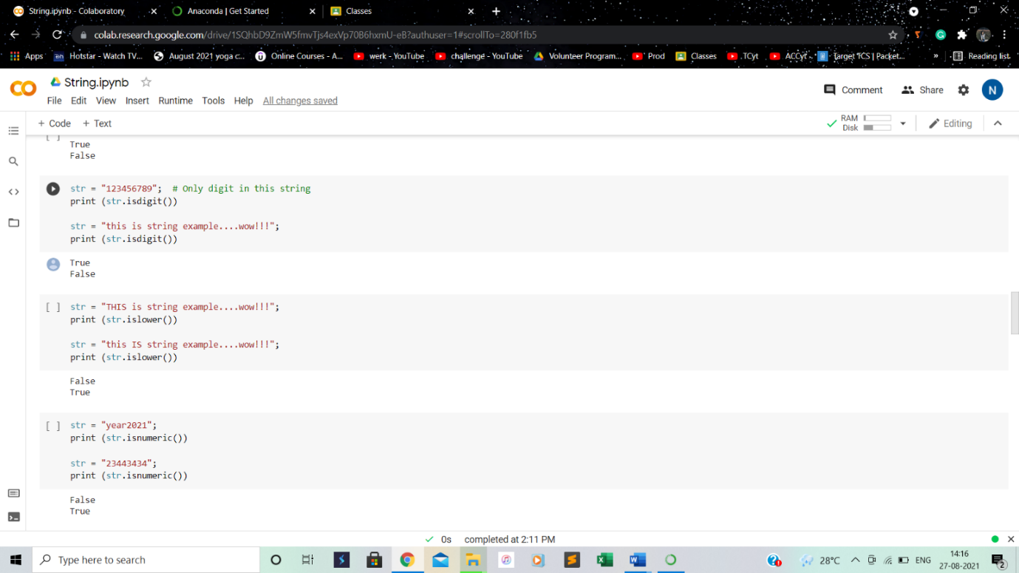

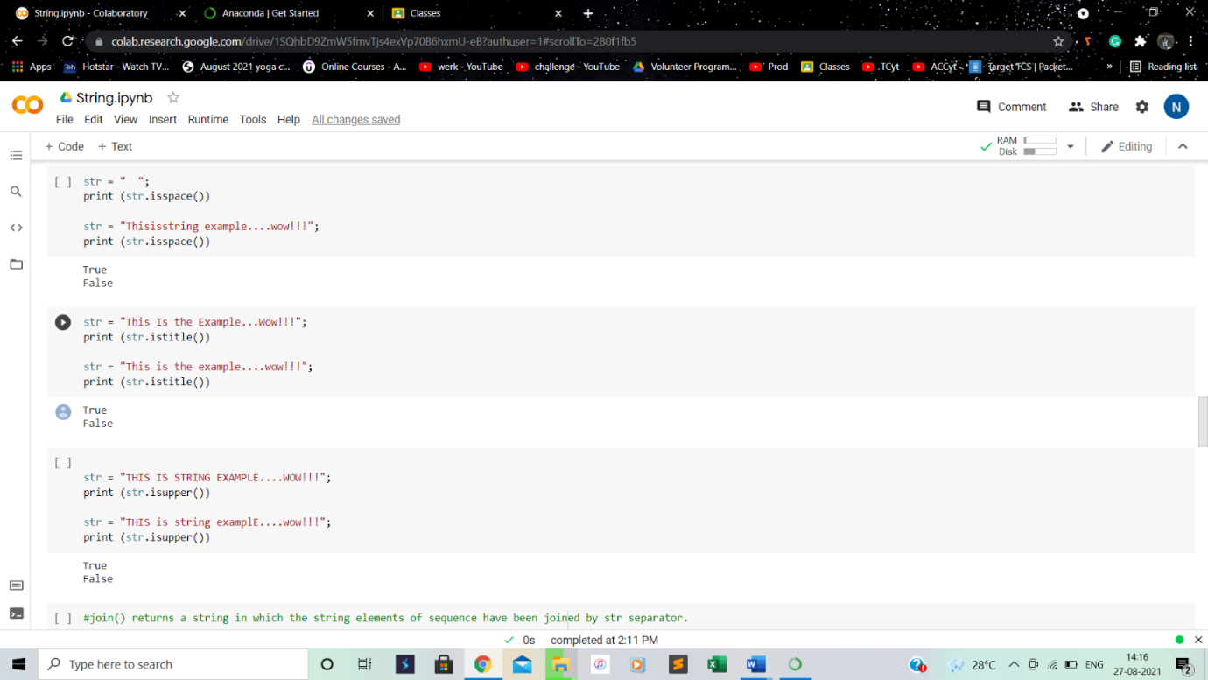

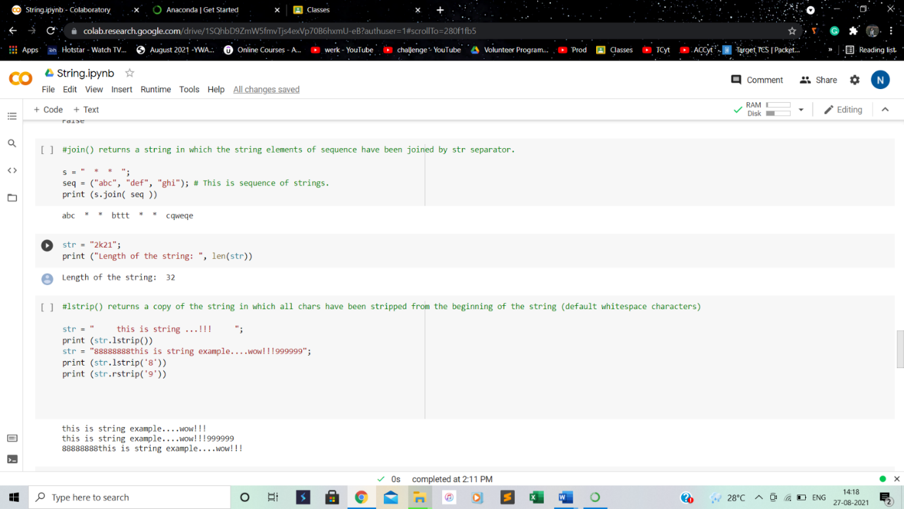

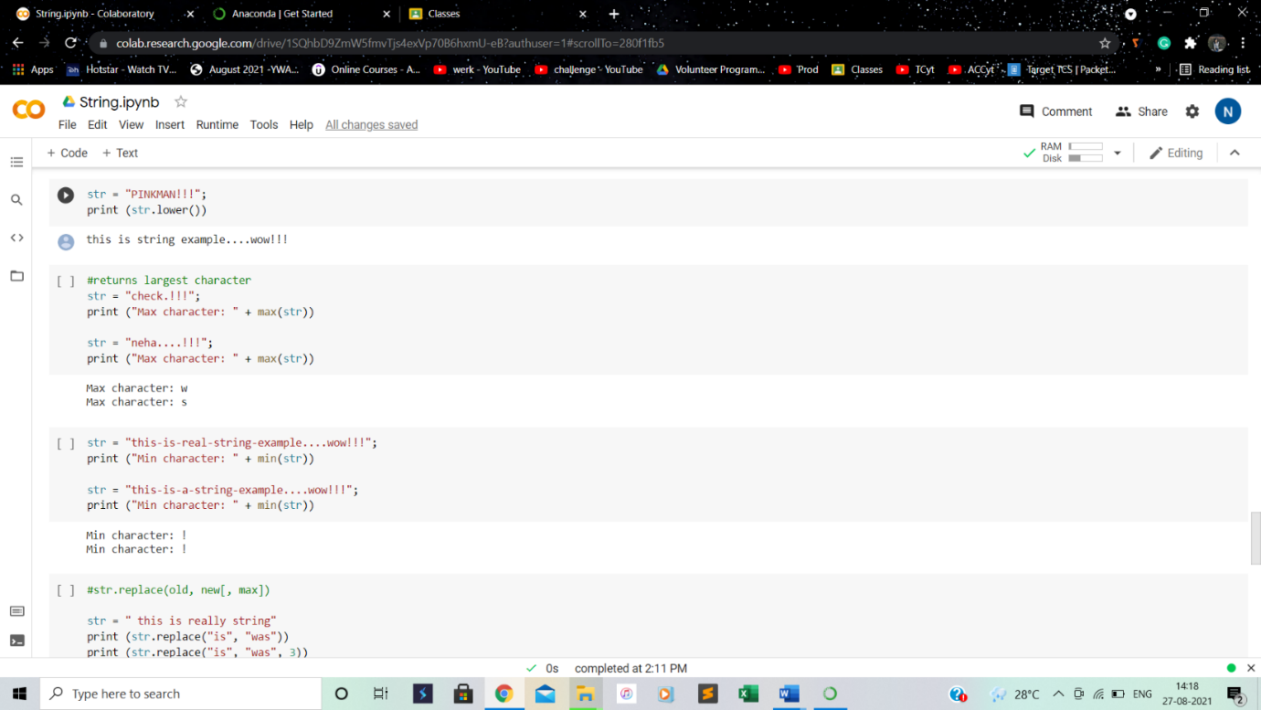

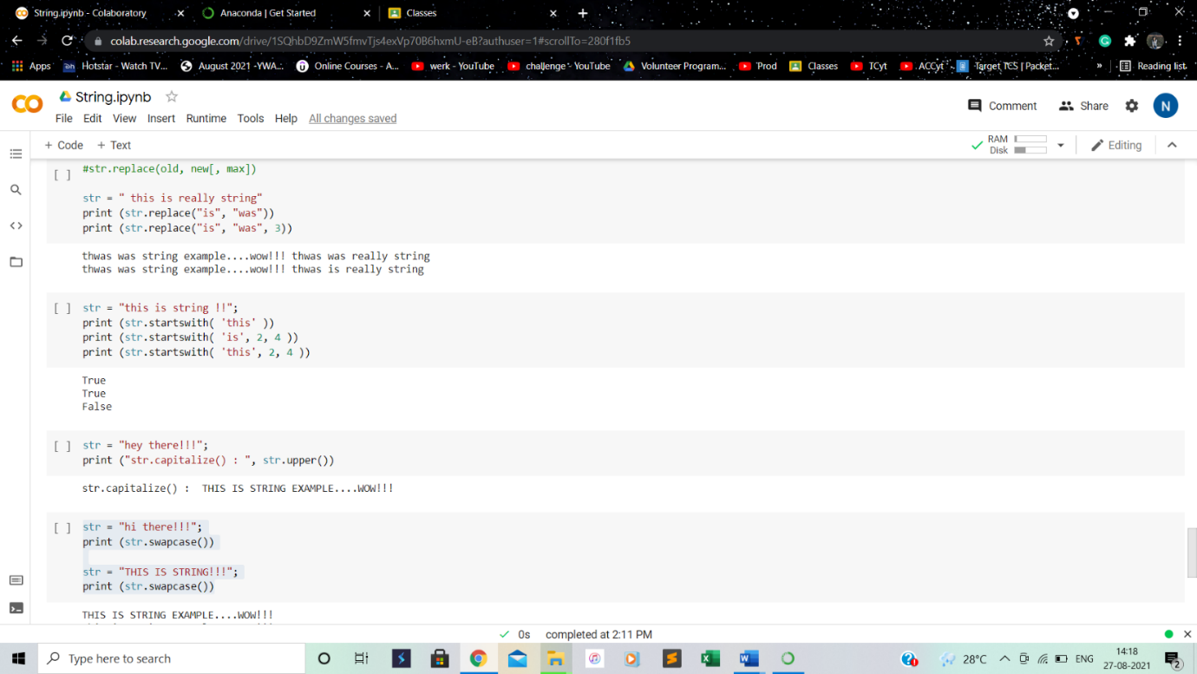

1. **LOOPS, BREAK AND CONTINUE:**

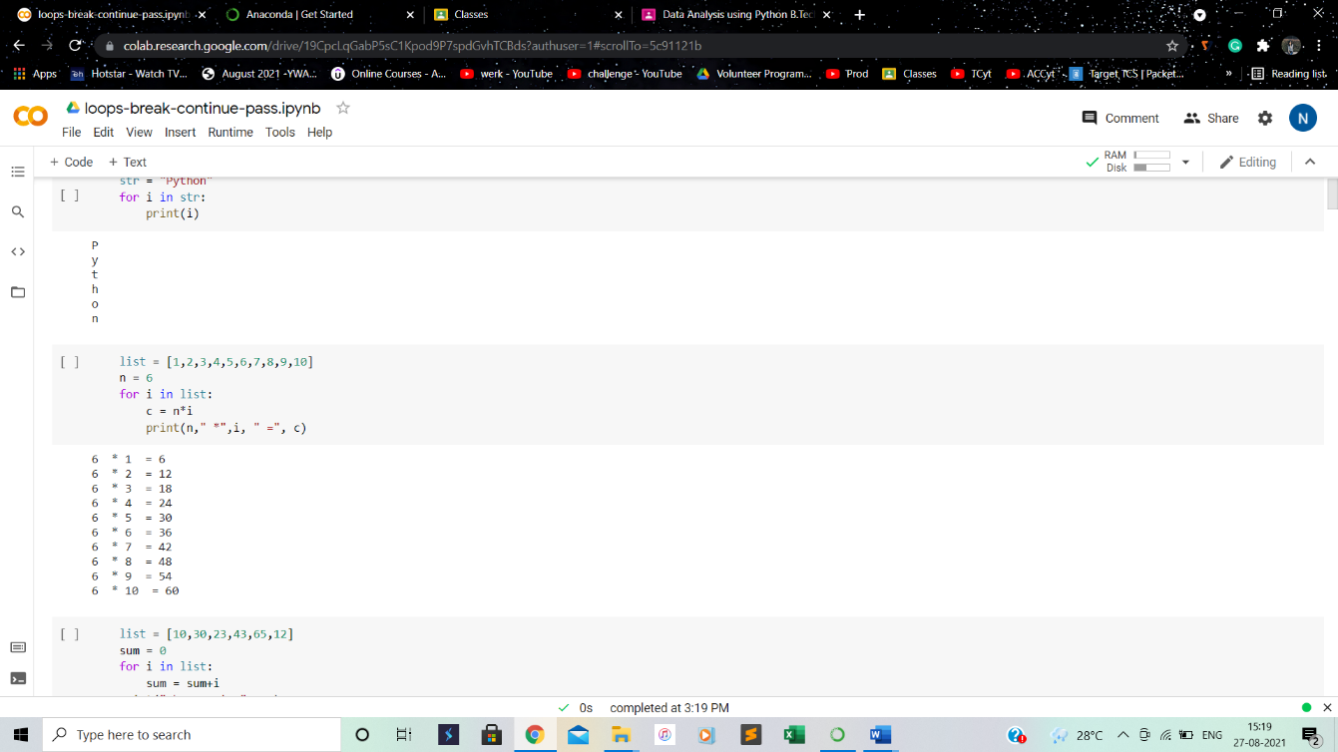

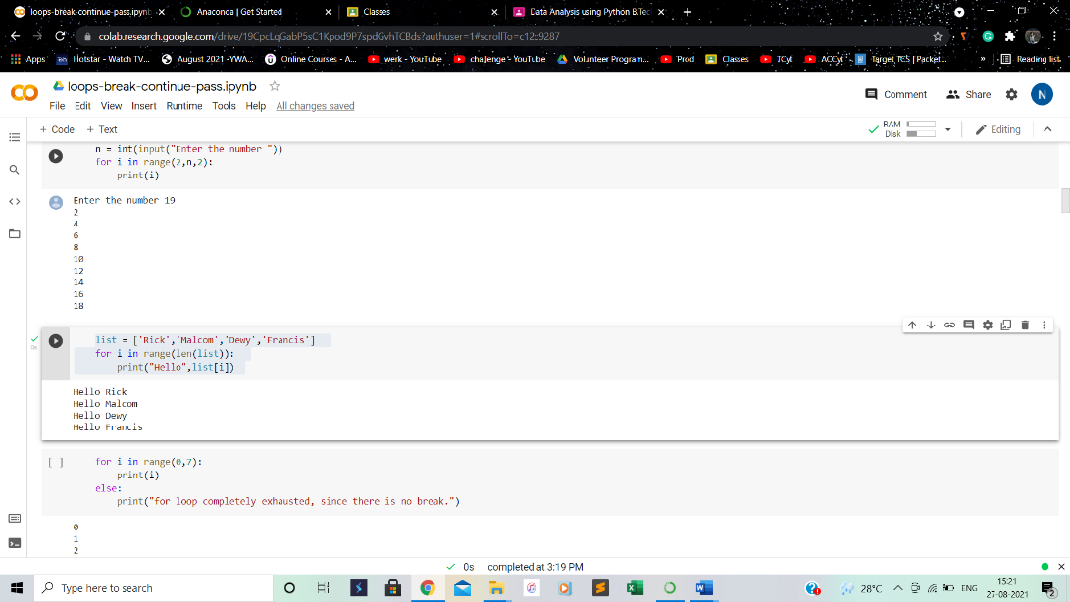

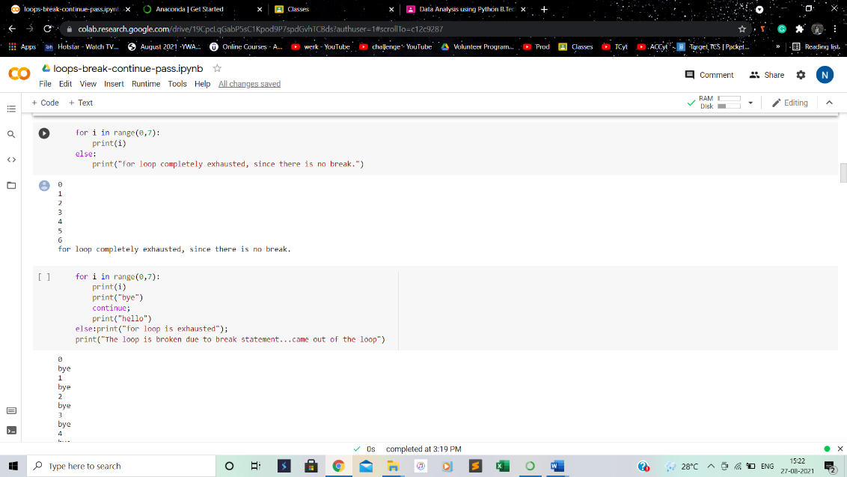

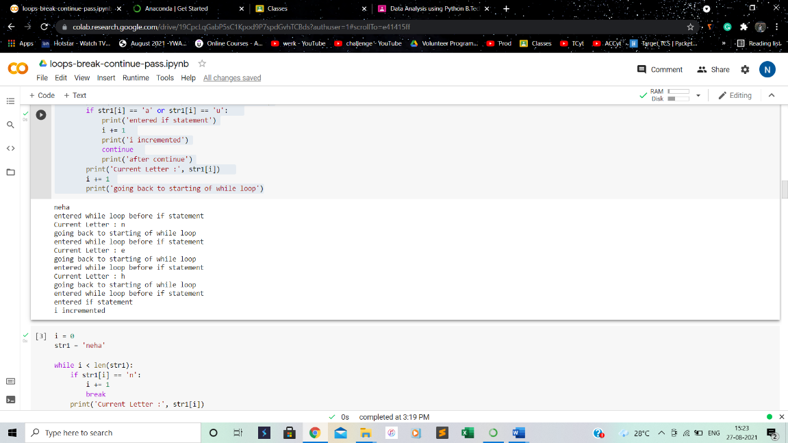

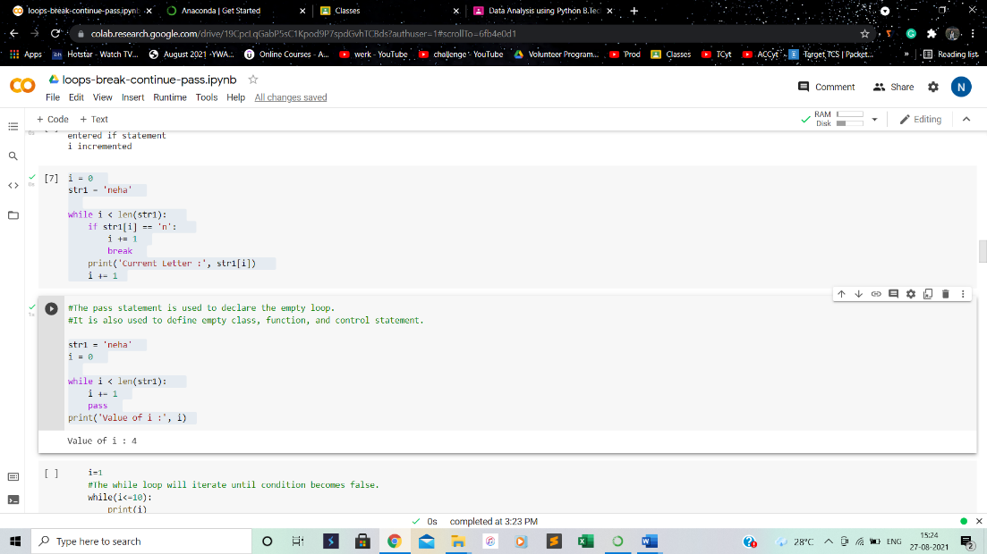

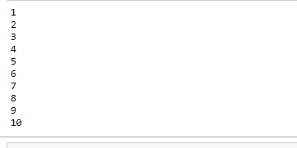

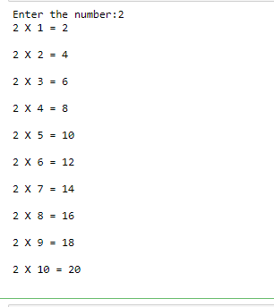

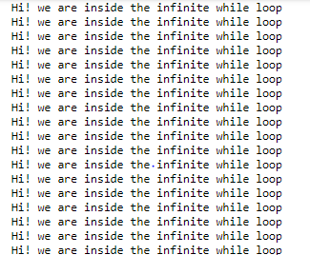

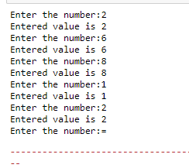

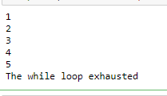

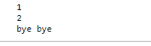

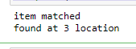

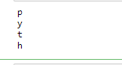

        n=n+1

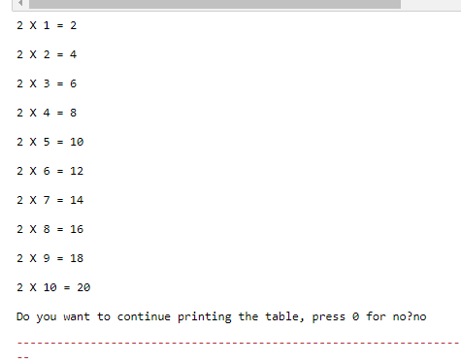

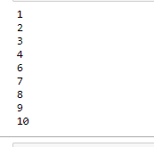

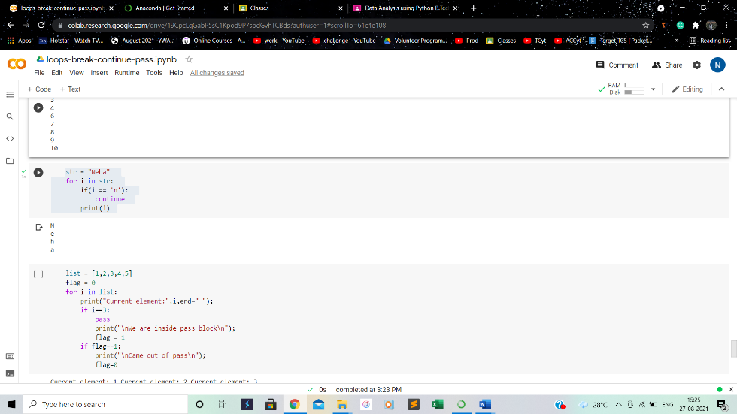

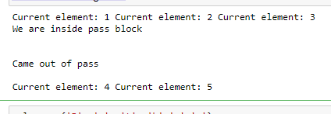

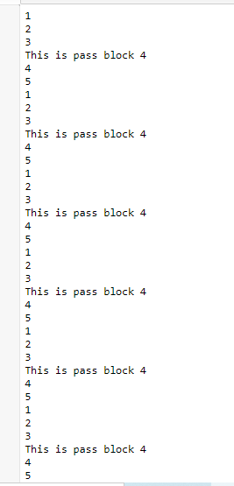

**Conclusion: Learnt to implement if-else, loops, lists and strings in programs.**

**3.PRACTICE PROGRAMS:**

**Learning objective: To implement basic concepts in four programs**

**Learning outcome: Understanding of basics concepts in four programs**

**Steps involved:**

1. Program for recharge plan for your service provider:

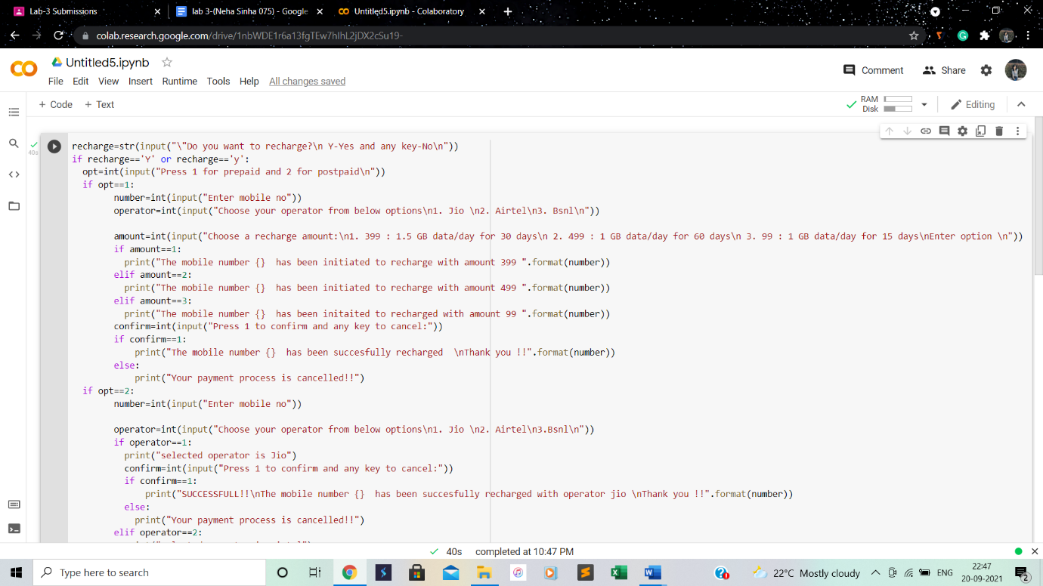

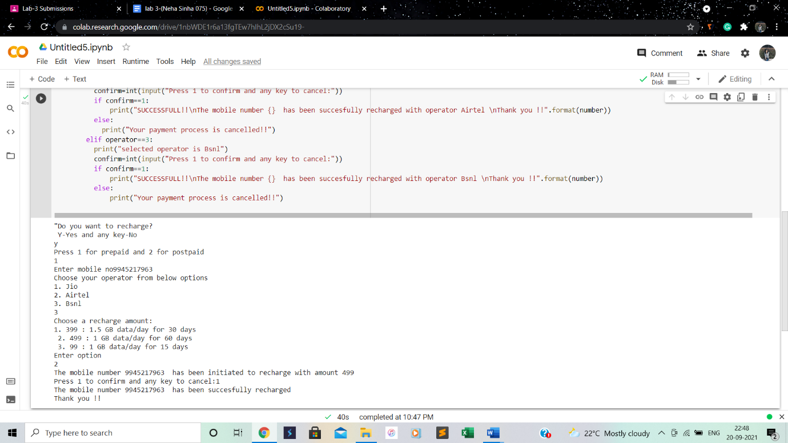

1. Design a system for landlord and tenant communication

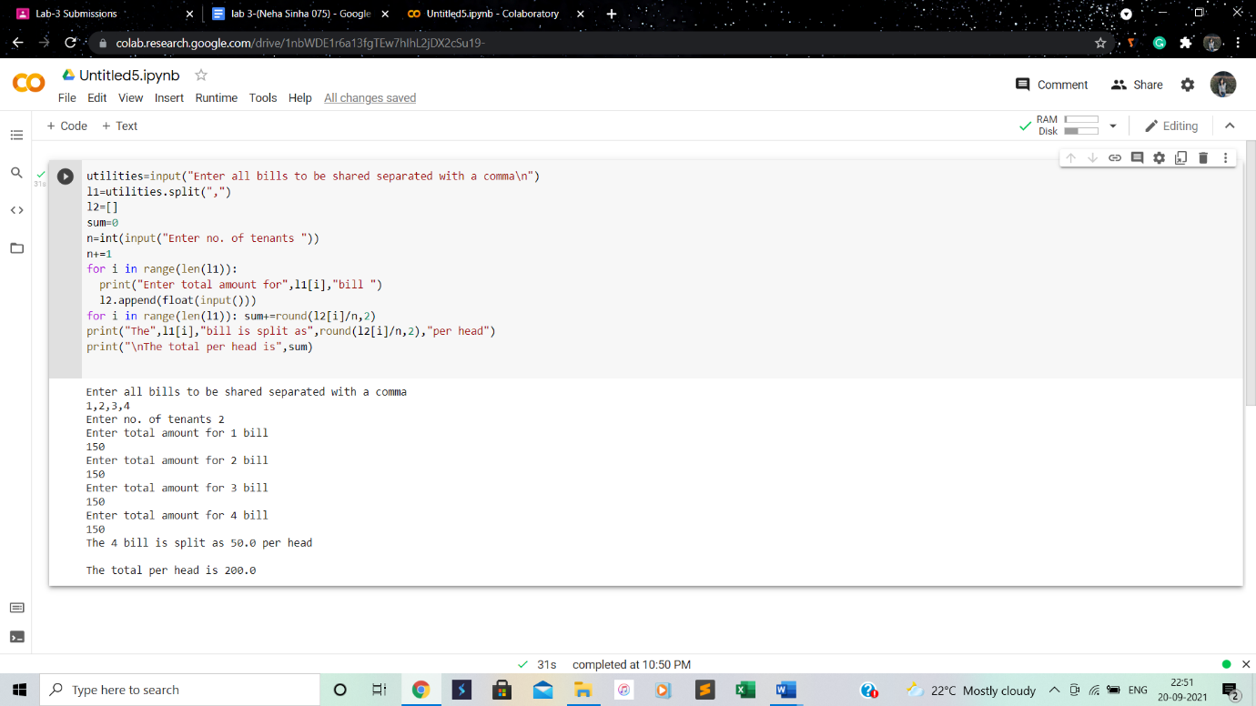

1. Design an inventory system

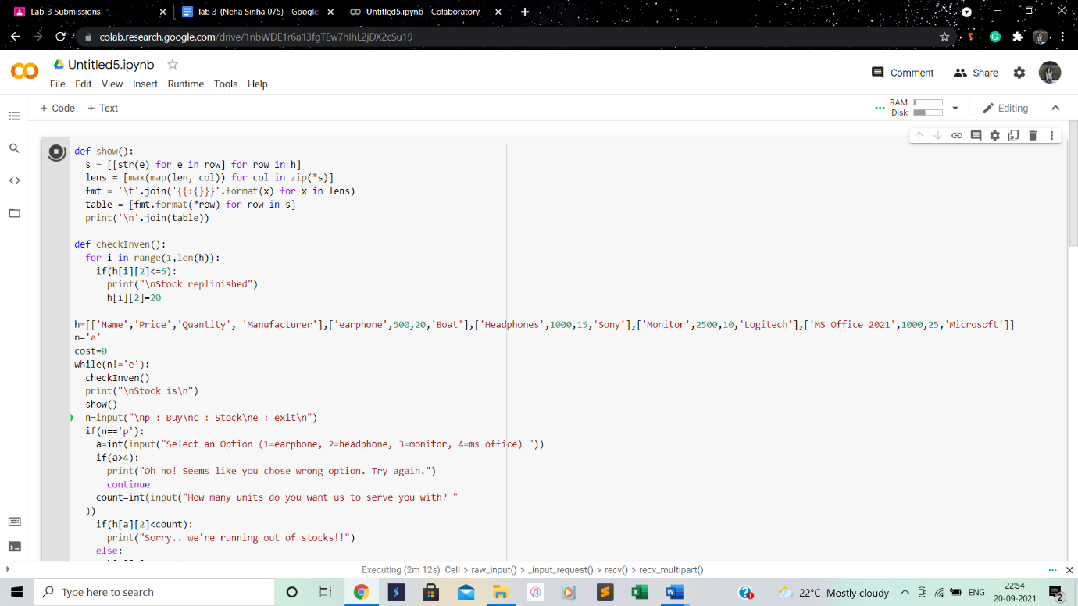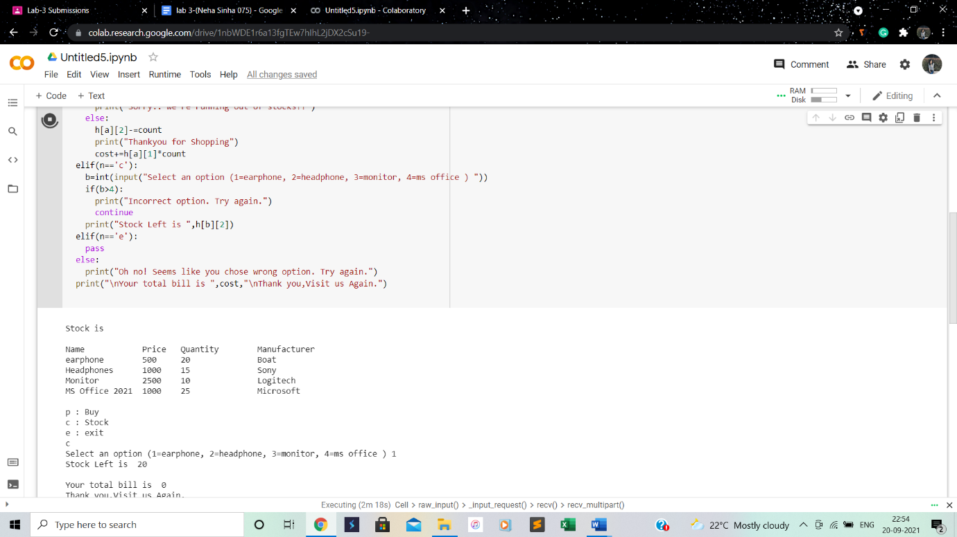

1. Design a food delivery app

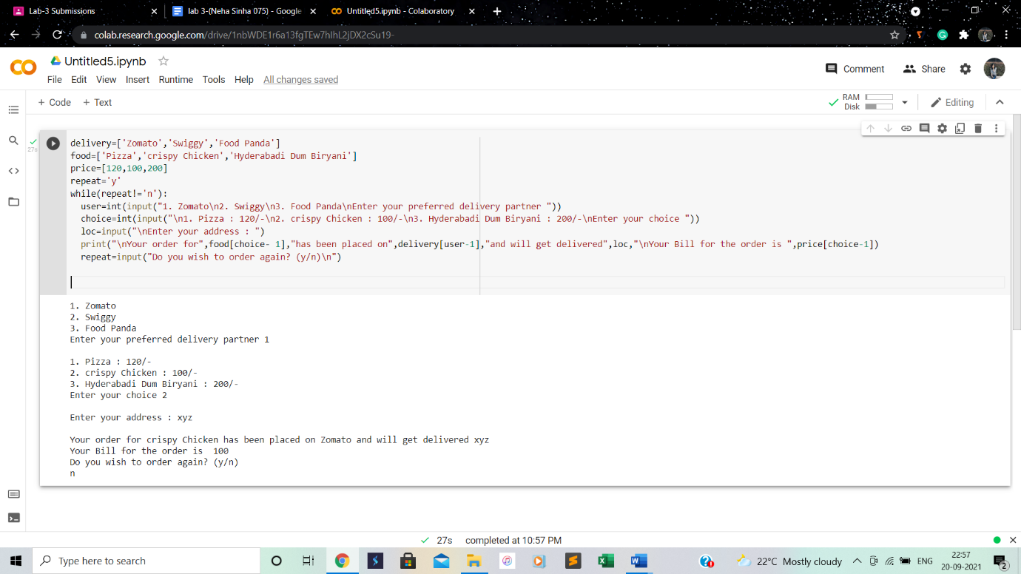

**Conclusion: Learnt to implement basic concepts in four programs**

**4.FUNCTIONS**

**Learning objective: To implement functions in the code**

**Learning outcome: Understanding of functions**

**Steps involved:**

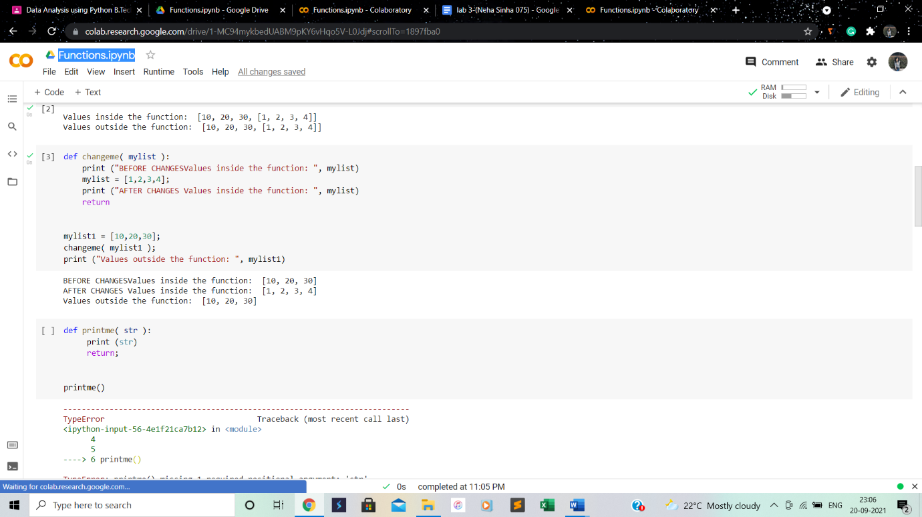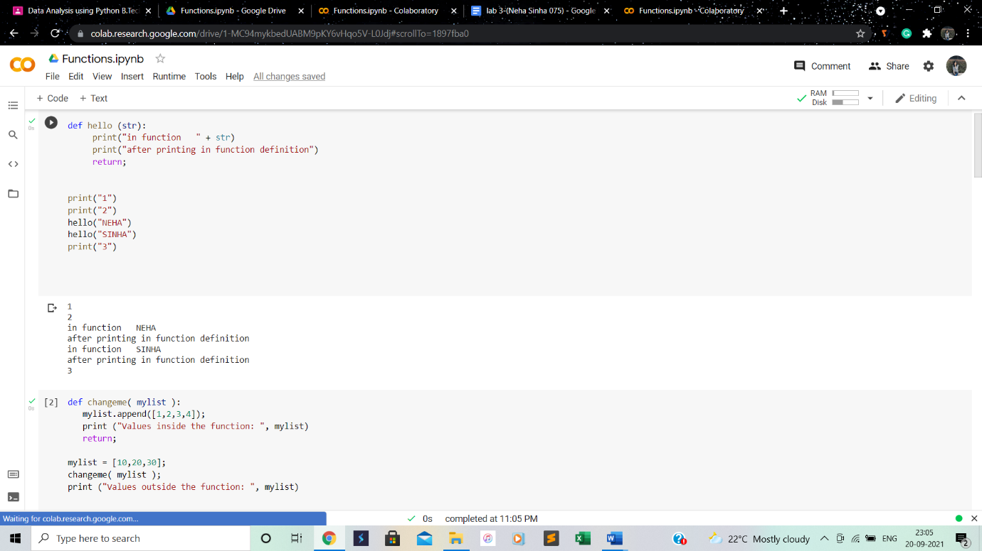

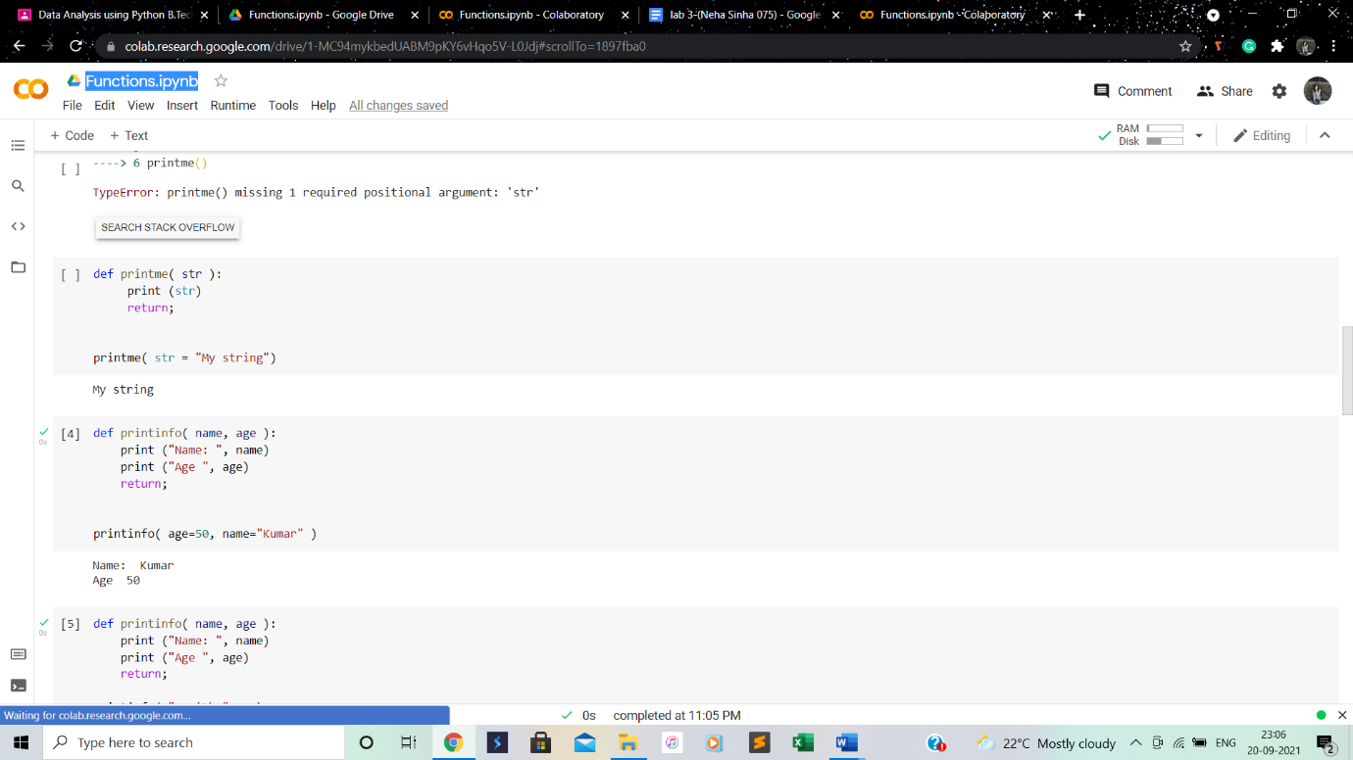

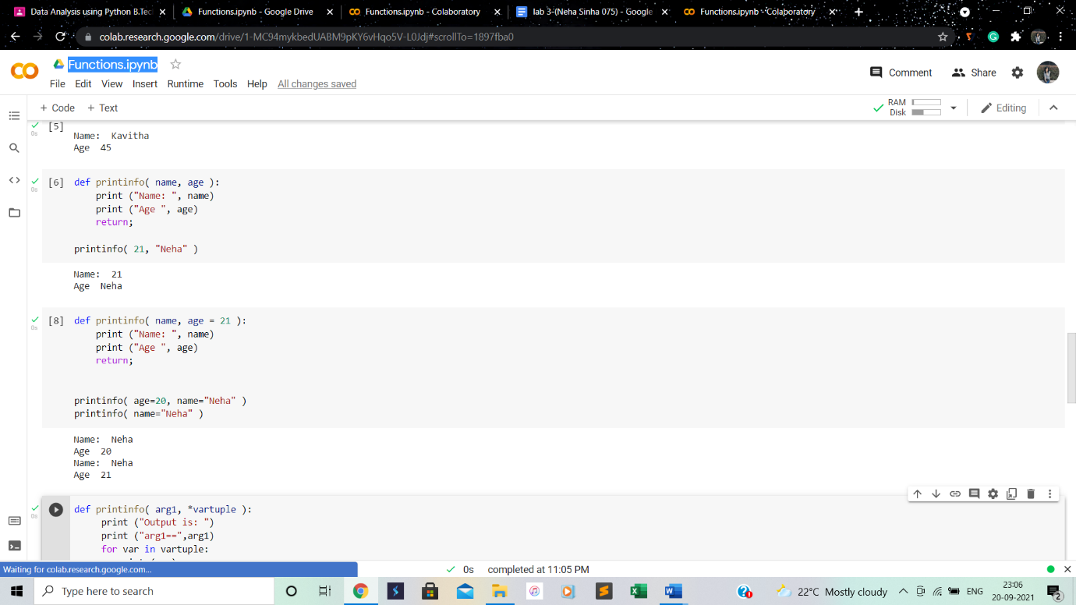

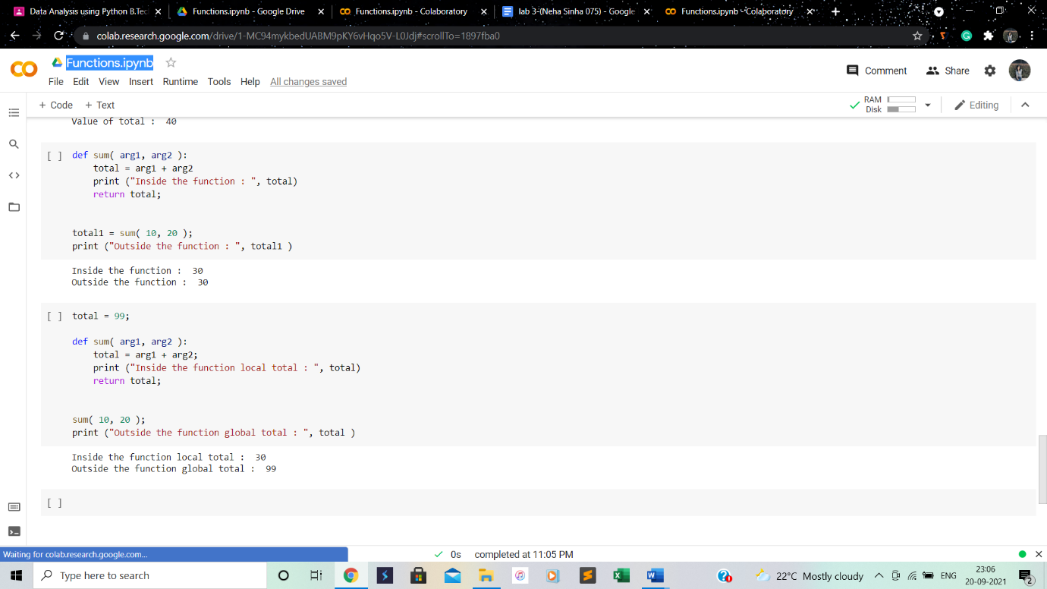

**Conclusion: Learnt how to implement functions in program**

**5.DICTIONARIES**

**Learning objective: To implement dictionaries in programs**

**Learning outcome: Understanding of dictionaries**

**Steps involved:**

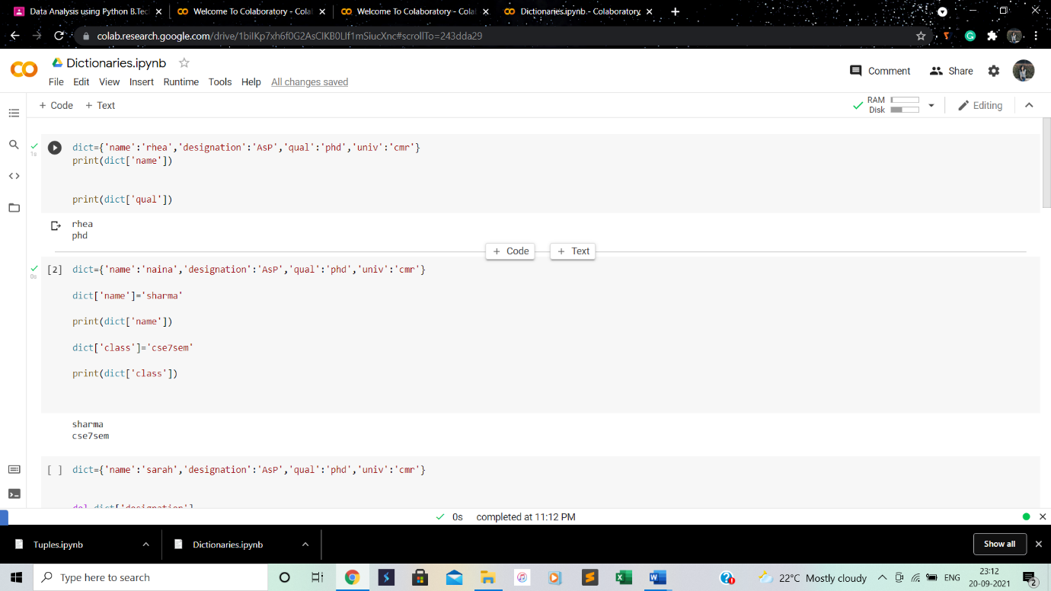

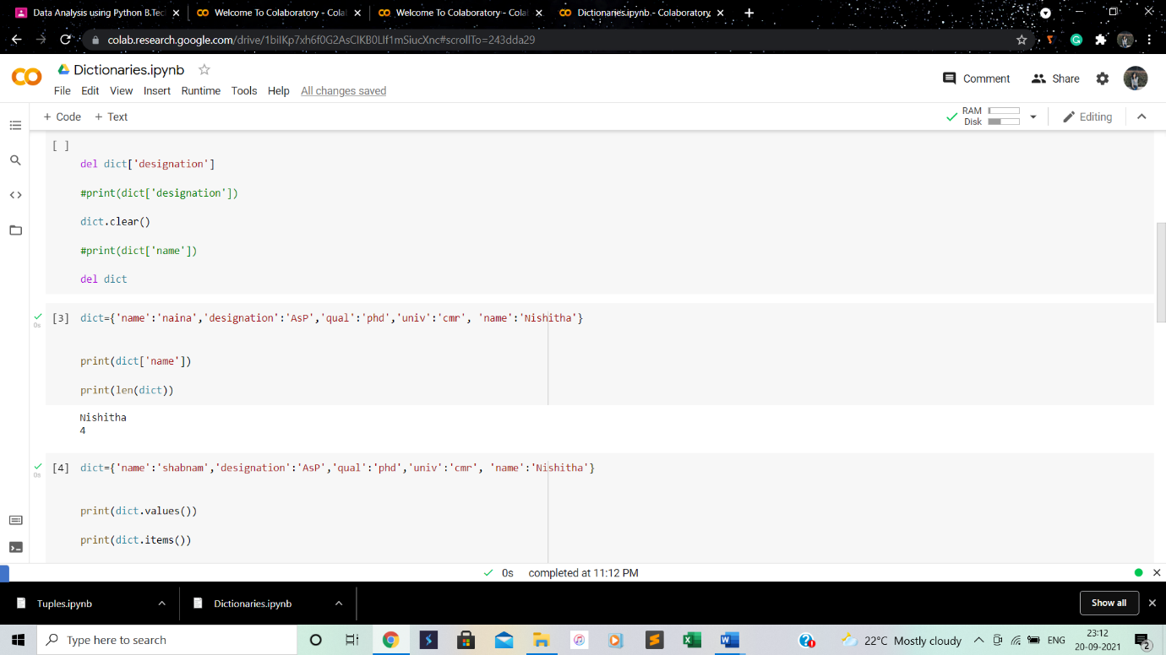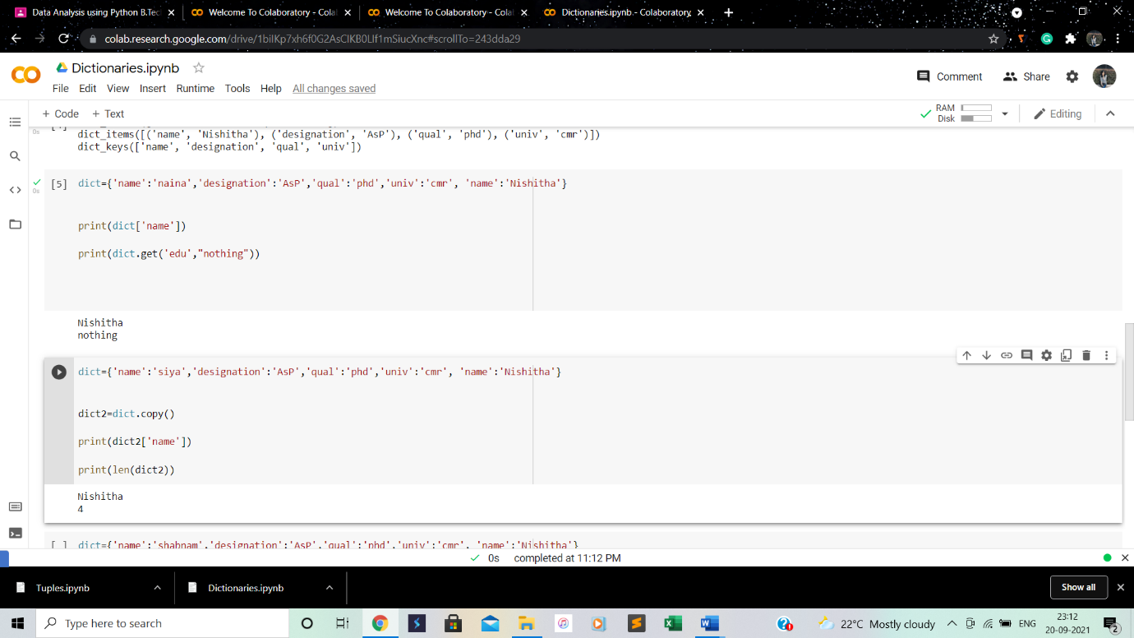

**Conclusion: Learnt how to implement dictionaries in a program.**

**6.TUPLES**

**Learning objective: To implement tuples in programs**

**Learning outcome: Understanding how to implement tuples in programs.**

**Steps involved:**

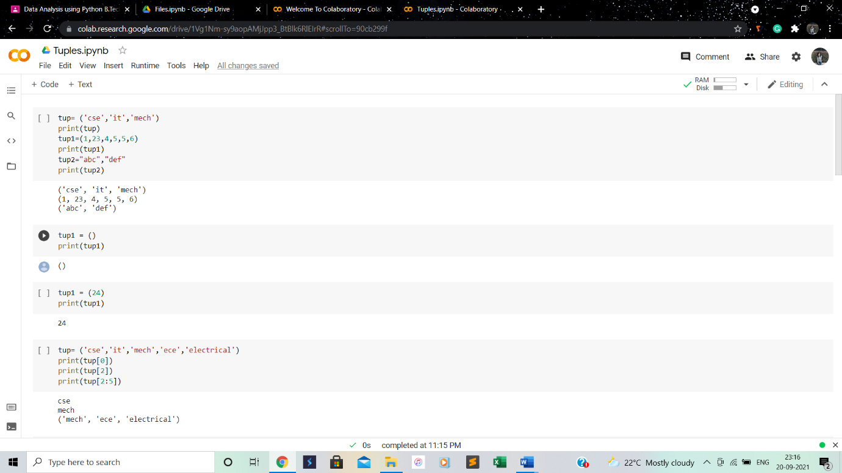

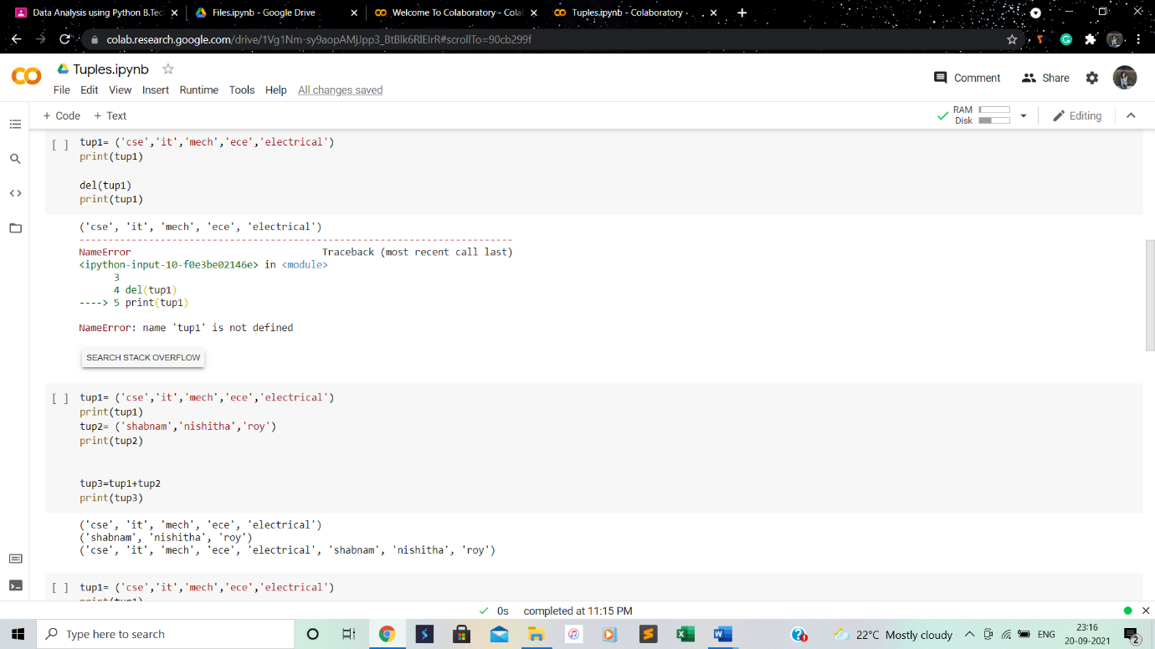

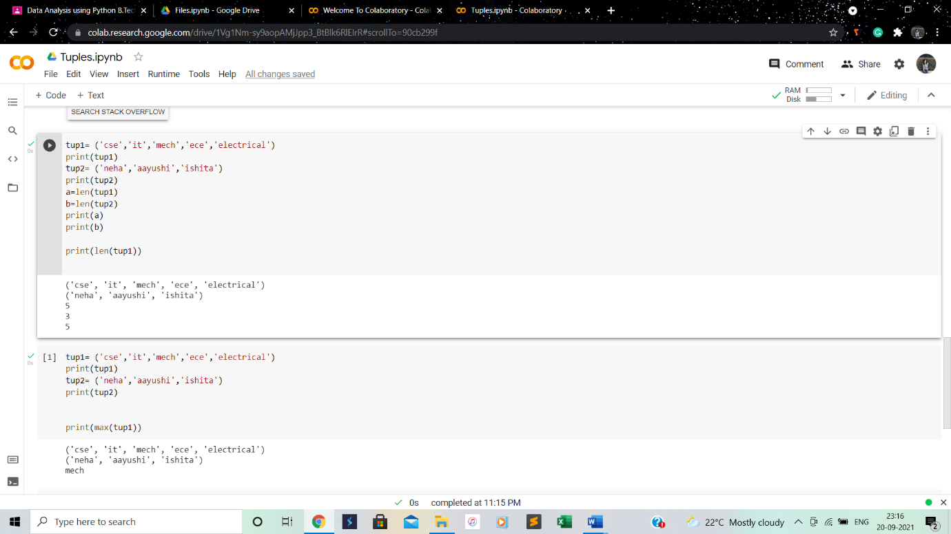

**Conclusion: Learnt how to implement tuples in programs.**

**7.FILES**

**Learning objective: To implement files in program**

**Learning outcome: Understanding of files**

**Steps involved:**

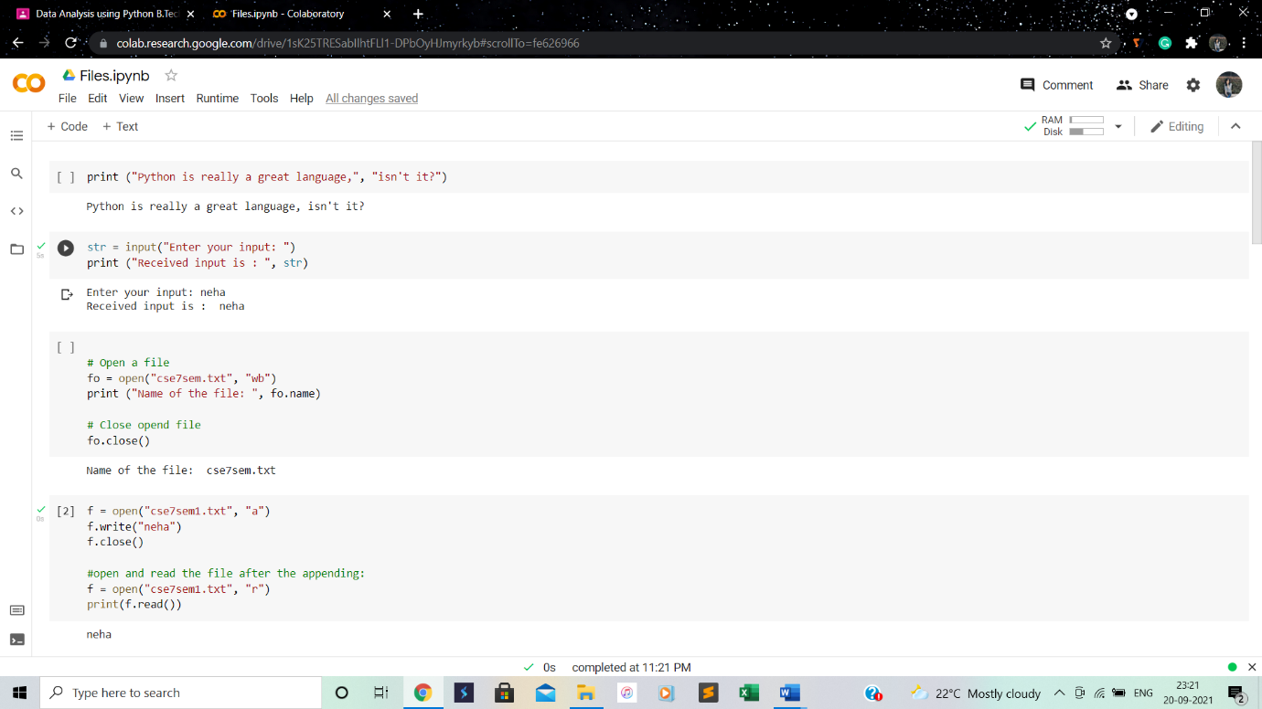

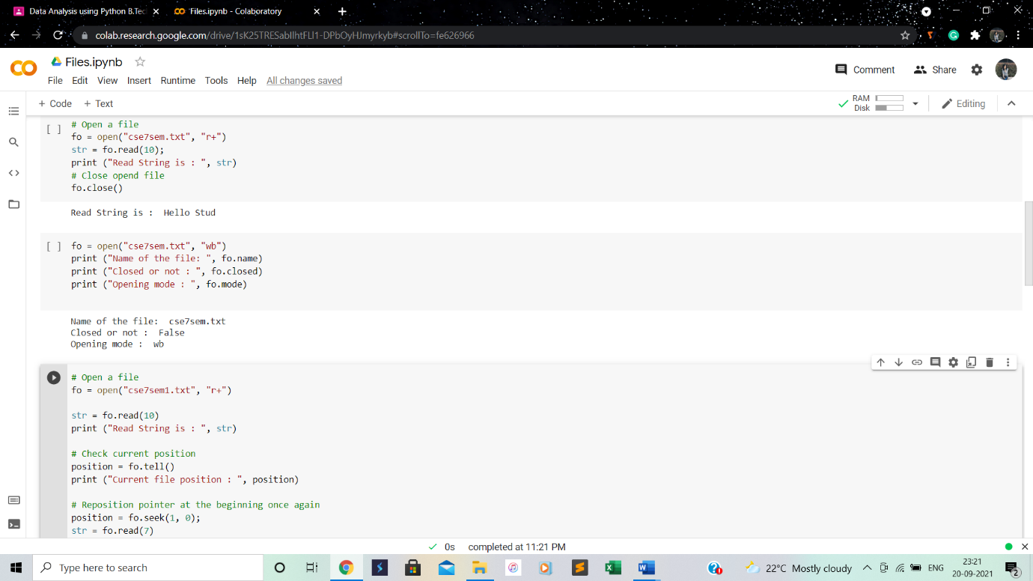

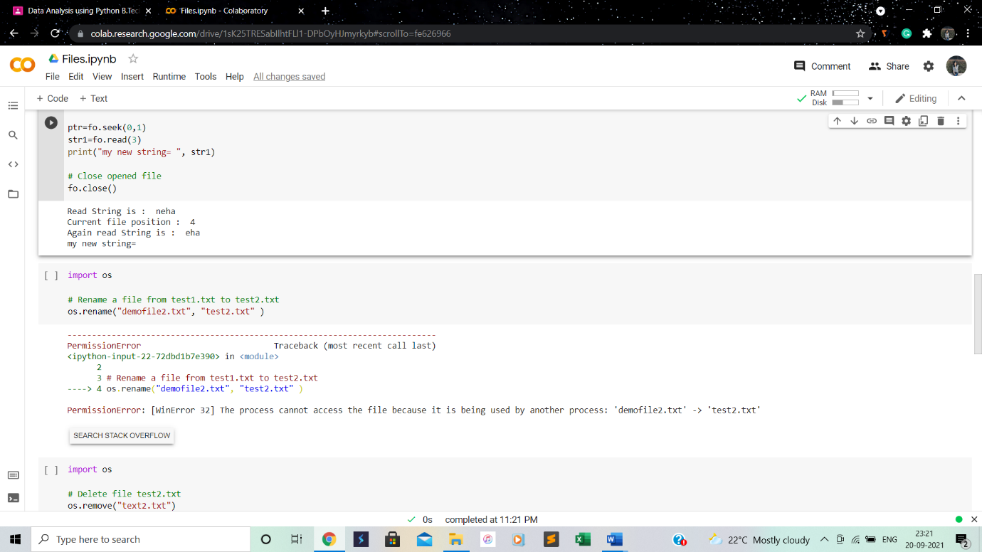

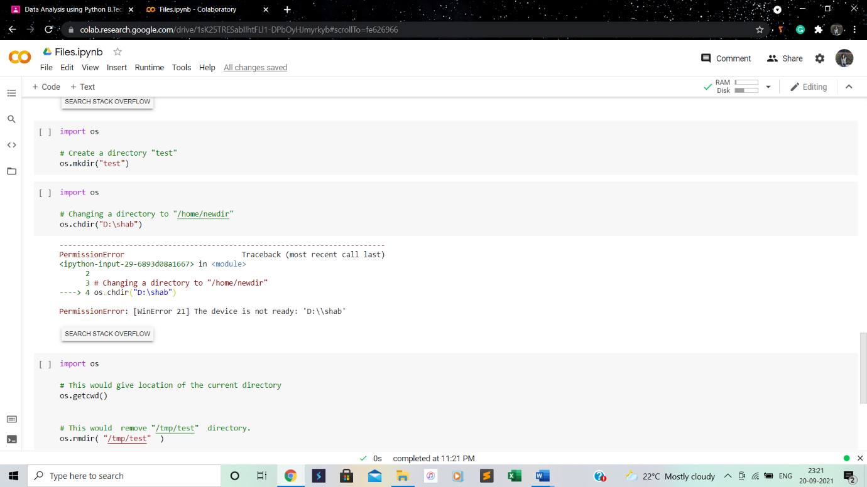

**Conclusion: Learnt how to implement files in programs**

**8.NUMPY ARRAYS, NUMPY ARITHMETIC AND MATHEMATICAL OPERATIONS**

**Learning objective: To implement NumPy arrays and perform arithmetic and mathematical operations**

**Learning outcome: Understanding implementation of NumPy arrays and perform arithmetic and mathematical operations**

**Steps involved:**

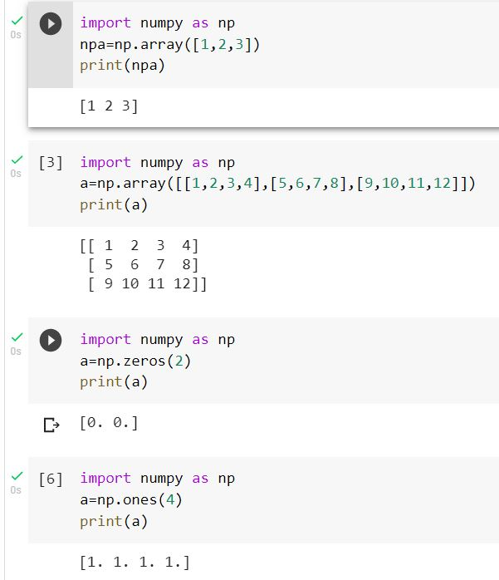

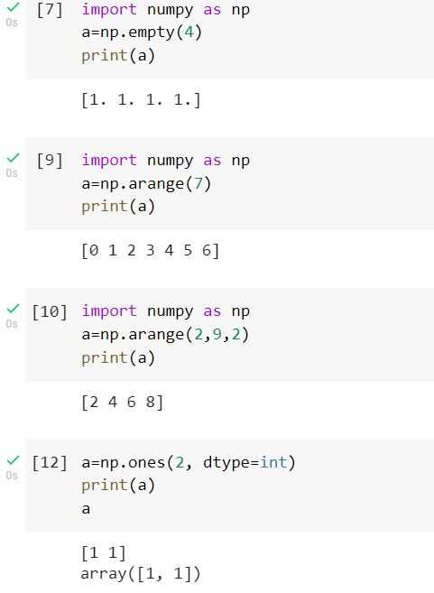

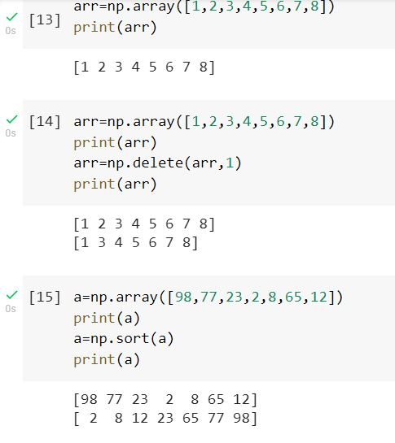

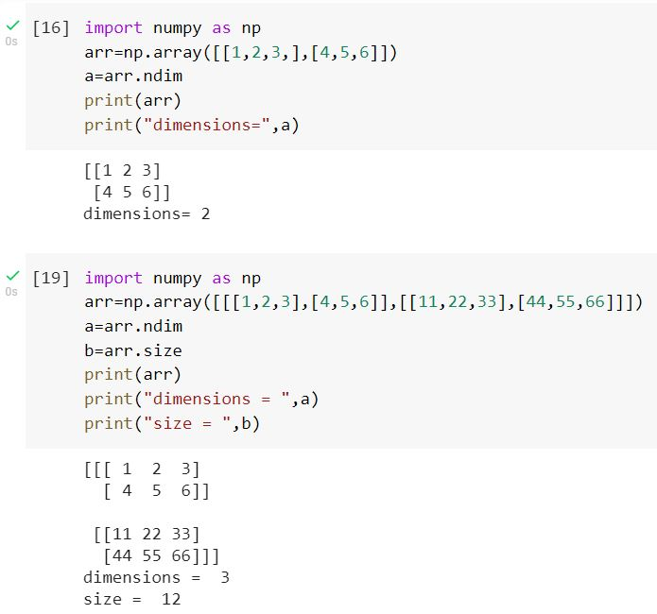

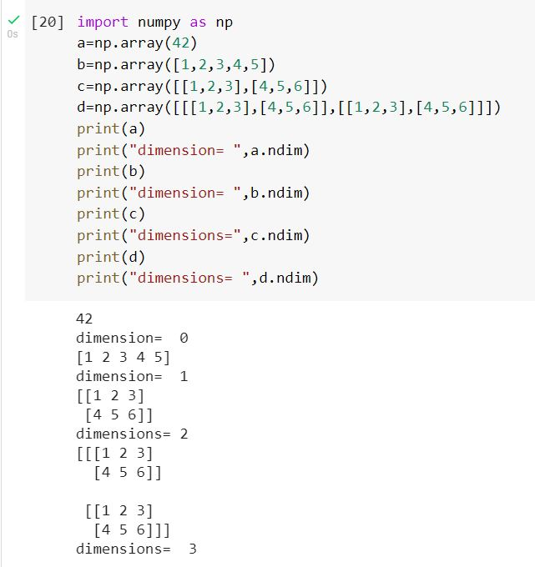

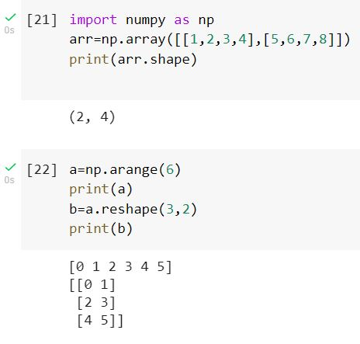

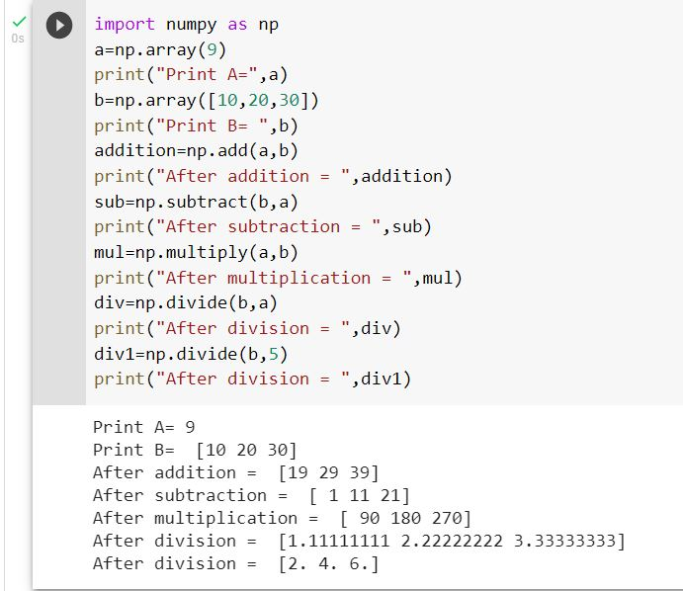

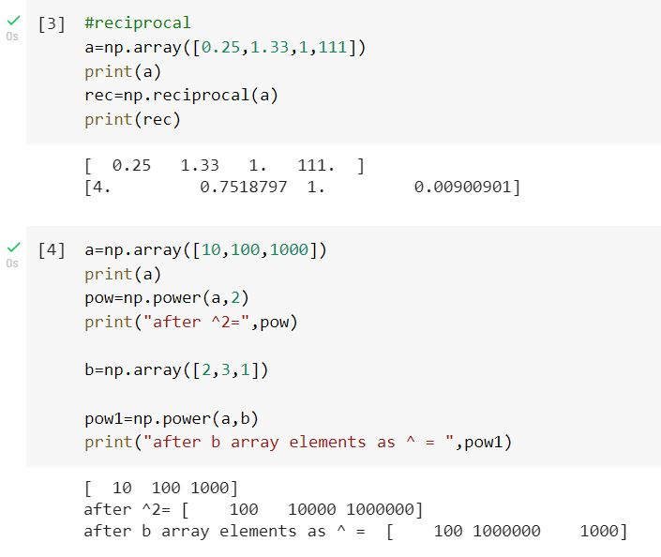

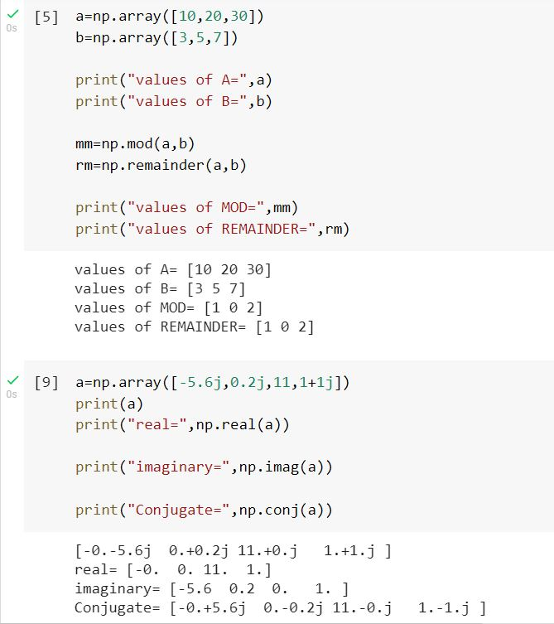

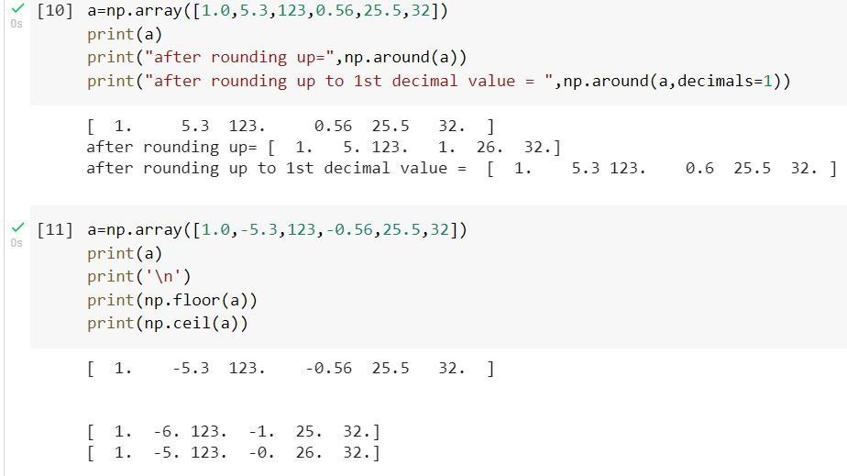

**Conclusion: Learnt to implement NumPy arrays, arithmetic and mathematical operations.**